**Salesforce Credential Setup**

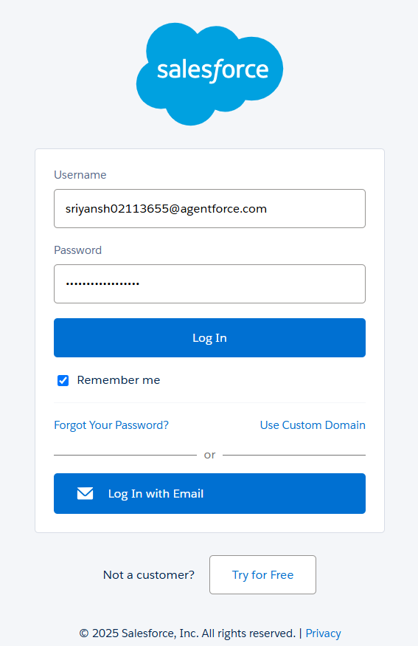I have successfully created a **Salesforce Developer Org** after completing the account verification process.

**✅ Steps Completed:**

1. **Developer Org Registration:**
   * Signed up for a Salesforce Developer Edition via [developer.salesforce.com](https://developer.salesforce.com).
   * Provided required details including name, email, company name, and selected a unique username.
2. **Email Verification:**
   * Received a verification email from Salesforce.
   * Confirmed my email address by clicking the verification link.
   * Set up a secure password and selected a security question for future verification.
3. 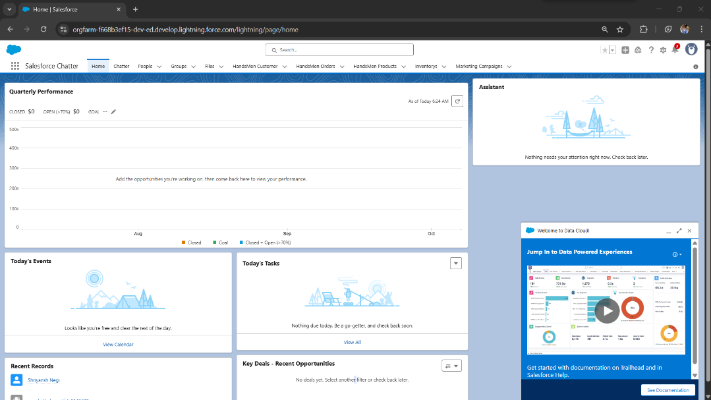**Access to Developer Org:**
   * Successfully logged into the Salesforce Developer Org.
   * Verified that the org is active and ready for development and testing purposes.

**This developer environment will now be used for hands-on practice, learning Salesforce features, and building real-world projects.**